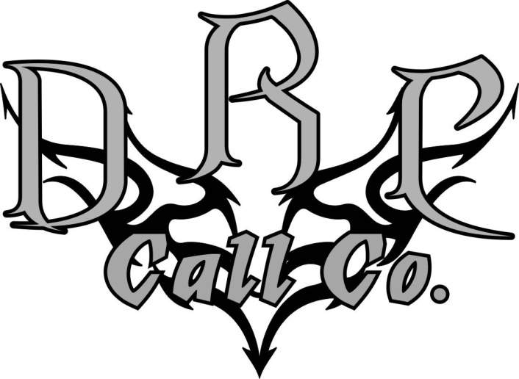
Thank you for your interest in being part of the DRCrew. We are constantly searching for talented individuals such as yourself to become part of the DRCrew. The DRCrew consists of an elite group of waterfowlers who know a quality product when they see it. These individuals are world class hunters and game callers. They are the driving force behind the success and expansion of the DRC brand. We feel this program will be very beneficial for the company and for you.
It is very important that you understand what this program involves. Not only will you be using our products but also will be a large part of our promotional efforts. DRCrew members must promote and believe in the DRC brand and do so with integrity and the best interest of DRC in mind.

If the information listed above is of interest to you and you hold the qualities and capabilities to be a part of this unique program, please fill out the following information.
Name:
Address:
Phone:
Email (Required):
Age:

1. Have you been or are you on any other pro-staffs? ____ Yes ____ No
If yes, which ones: _______________________________________________________________

2. What is your favorite species to hunt and why? ____________________________________________
_____________________________________________________________________________________

3. Activities other than hunting?: __________________________________________________________
__________________________________________________________________________________
4. Do you have a current job in the outdoor market? __________________________________________
5. Calling Competition history? ___________________________________________________________
_____________________________________________________________________________________
If none, do you have any plans to start competing? ____________________________________

6. Do you have a Facebook account?______ If yes, are you friends with Cory Loeffler?________(if no, please send a friend request)

7. In a few short sentences please describe why you feel that you would make a great candidate for the DRCrew. (this is your shot to get our attention)

Please allow us time to sort through the applications. There are a lot of people applying, so bear with us. We will get back to you ASAP.

Again, thank you for your interest in the DRCrew. Please send this back to us by one of the following ways:

Fax: 216.681.4709
Email: drcrew@deathrowcalls.com
Mail:
DRC Call Co.
112 St. Paul Ave N
Thief River Falls, MN 56701

